Piecewise Exponential Model – Results Summary
The Bayesian piecewise exponential model converged cleanly: Stage IV carries about 4.7× the death hazard of Stage I, and 5-year survival for a 60-year-old ranges from about 85% (Stage I) to about 45% (Stage IV). Sex makes almost no difference.

Data
The model uses 521 patients and 173 deaths (33%); the other 67% are right-censored. Time is in years.
- Cohort: the 529-patient filtered file minus 8 patients with grade GX or missing.
- Variables: stage (I–IV, reference I), age centered at 60 per 10 years, sex (reference female, same as our Weibull model), histologic grade.
- Grade: G1 and G2 are combined because G1 has 13 patients and zero deaths. Death rates rise with grade: G1&2 19%, G3 36%, G4 73%.
- Time intervals: 0–1, 1–2, 2–3, 3–5 and 5+ years, with 48 / 32 / 29 / 39 / 25 deaths. Everything after 5 years is one interval because only about 2 deaths occur after year 8.
- Long format: survSplit() gives one row per patient per interval (1,746 rows). Each row records the years at risk in that interval (exposure) and whether the patient died there.

Model
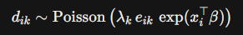
The hazard is a step function: a constant baseline rate λₖ inside each interval, multiplied by e^(xβ) for each patient's covariates. With the long data, this is exactly a Poisson model with an offset (the "Poisson trick"):

Here d is death in interval k (0/1) and e is the years at risk in that interval.
Priors
- λ₁…λ₅ ~ Gamma(0.01, 0.01): the baseline death rate per year in each interval.
- β₁…β₇ ~ Normal(0, 5²): the log hazard ratios for Stage II/III/IV, age, male, G3 and G4. This prior is weak.
Sampler (hand-coded in base R, no Stan)
- Gibbs step for each λₖ: its full conditional is Gamma(a₀ + deaths in k, b₀ + Σ exposure · e^(xβ)), the same Poisson–Gamma update as Quiz 2 Q1.
- Metropolis step for each βⱼ: there's no closed-form full conditional, so the sampler proposes a new value and accepts it with probability min(1, posterior ratio).
It runs 3 chains × 30,000 iterations from different random starts, with a burn-in of 2,000, leaving 84,000 posterior draws.

Convergence
The chains converged quickly and mixed well; every check passes.
Check | Result | Target
Metropolis acceptance rate | 0.32–0.47, same in all 3 chains | about 0.25–0.5
Burn-in (trace of first 3,000 iterations) | Chains reach the posterior within about 50 iterations | Burn-in of 2,000 is plenty
Trace plots | 3 chains overlap completely, no drift | Overlapping, no trend
R-hat (gelman.diag) | 1.00–1.01 for all 12 parameters | < 1.05
Effective sample size | 3,300 (Stage IV) to 14,000 (age) | > 1,000
Autocorrelation | Near zero by about lag 40 for Stage IV and G4 | Expected for Metropolis; already reflected in the effective sample size

Hazard ratios
Stage, age and grade clearly raise the hazard of death; sex does not.
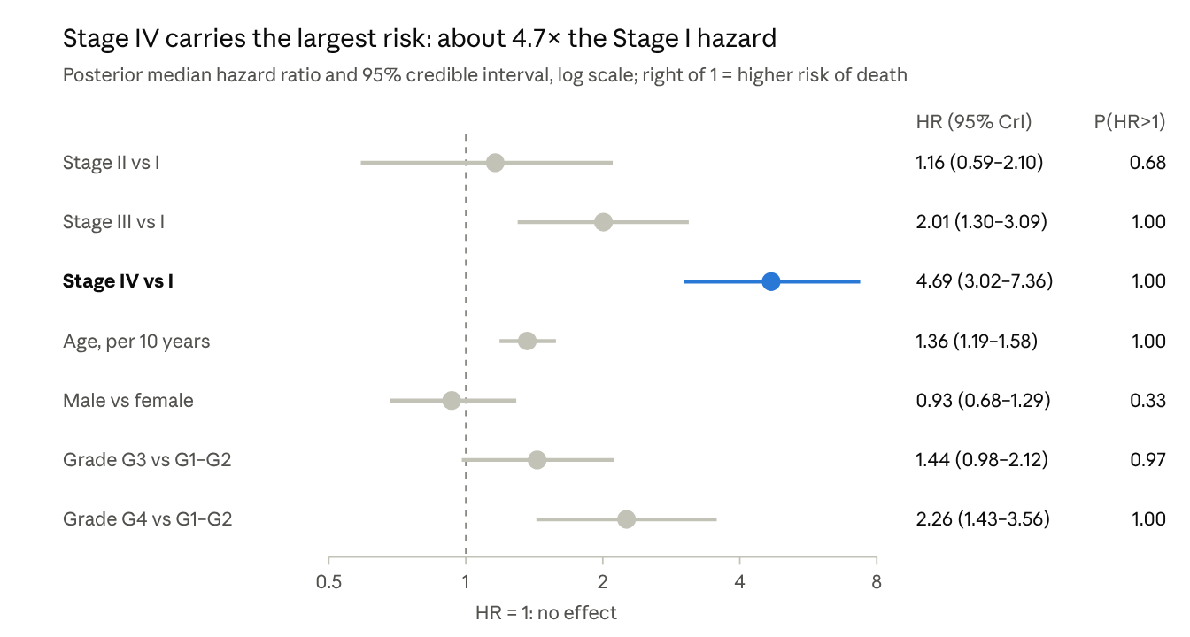
R output, Step 7 · 84,000 posterior draws, 3 chains
Each hazard ratio holds the other variables fixed. It compares the instantaneous risk of death: Stage IV patients face about 4.7× the Stage I risk at any moment, which is not the same as being 4.7× as likely to die overall. P(HR > 1) is the posterior probability that the variable raises the hazard.

Survival curves
The stages separate clearly, and the male and female curves are nearly identical. Each line is the posterior median S(t) for a 60-year-old with grade G1–G2; the band is the 95% credible interval; dotted lines mark the interval cutpoints.
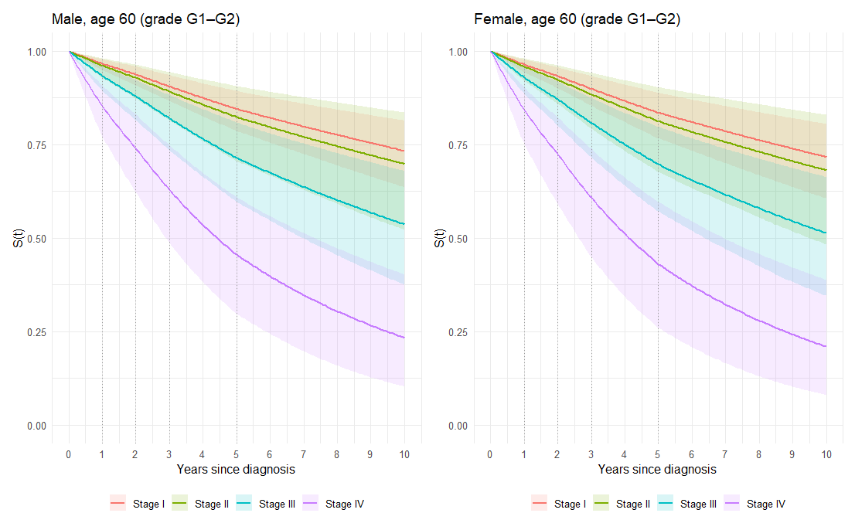
5-year survival, median (95% CrI)
Stage | Male, 60 | Female, 60
I | 0.85 (0.79–0.89) | 0.84 (0.77–0.89)
II | 0.82 (0.71–0.91) | 0.81 (0.68–0.90)
III | 0.71 (0.60–0.81) | 0.70 (0.57–0.80)
IV | 0.46 (0.30–0.61) | 0.43 (0.26–0.60)
The small bends at 1, 2, 3 and 5 years are where the step-function hazard changes, a built-in feature of this model.

For discussion
- The baseline hazard is roughly flat. λ₁…λ₅ are all about 0.030–0.037 deaths per person-year, with overlapping intervals. After adjusting for covariates, risk barely changes over time. That favors a simple exponential, or a Weibull with shape ≈ 1, and is worth comparing against the Weibull and lognormal fits.
- Stage II isn't clearly different from Stage I (P(HR > 1) = 0.68). It has only 57 patients, hence the widest band.
- Sex has no clear effect. The male HR is 0.93 with an interval spanning 1. Female stays the reference, consistent with the Weibull model.
- Grade adds information beyond stage. G4 has about 2.3× the hazard of G1–G2, even after adjusting for stage.
- Treat 10-year survival with caution. After year 5 the model assumes one constant hazard, and only 41 patients were followed past 8 years.
Next steps
- ☐ Run Step 9: compare with the frequentist Poisson glm and Cox model (cox.zph checks proportional hazards)
- ☐ Put the same male/female age-60 plots side by side for all three models
- ☐ Fix the combined plot's legend: plot_layout(guides = "collect")

